**UNIVERSITY OF NEW HAMPSHIRE**

**STUDENTS FOR THE EXPLORATION AND DEVELOPMENT OF SPACE**

Thomas Collins

May 5th, 2020

**OVERVIEW**

University of New Hampshire Students for the Exploration and Development of Space is a multidisciplinary organization consisting of students from every year and degree. Over the past three years UNH SEDS will have hosted 24 Senior Capstones ranging from Mechanical, Electrical, Computer, and now, Engineering Physics. Senior members can manage the student body and develop technical skills all while working towards building UNH’s first, student build Hybrid Rocket.

**PROJECT STATEMENT**

Team Project Statement

The goal of this year’s project was to design, manufacture and fly a hybrid rocket to 10,000 feet as part of the Spaceport America Cup in June 2020. The team members were assigned to one of four teams, Avionics, Frame, Propulsion, and Operations. The main engineering objectives included, achieve an apogee as close to 10,000 feet as possible, successful deployment and landing of a research payload, full rocket recovery by dual deployment parachute strategies and live GPS tracking. Due to the cancellation of the competition, our goals shifted to preparing next year’s team as much as possible for their competition.

Personal Project Statement

The goal of my personal senior project was to lead, design, and manufacture the Frame structure for the hybrid rocket. In terms of the organization, this included leading two other ME senior projects, and numerous underclassmen. In terms of the technical portion of my senior project, I designed, analyzed, and manufactured the rocket body. Through FEA, SOLIDWORKS, and general structural analysis I produced a structure capable of handling the forces of RUNAWAY (our hybrid engine) and overall aerodynamic flight.

Apart from the Frame portion of my personal project statement, I assisted the team in other aspects. Participation and ownership of portions of the propulsion, avionics, and operations team were within my responsibility.

**MILESTONES**

Conducted Tests

|  |  |  |  |  |
| --- | --- | --- | --- | --- |
| Date | Type | Description | Status | Comments |
| 8/20/19 | Ground | Hotfire Test | Major Issues | Nozzle Axial Stress Failure |
| 4/6/20 | Ground | Hotfire Test | Partial Success | Inadequate Pressure + Temperature |
| 4/12/20 | Ground | Hotfire Test | Partial Success / Major Engine Failure | Nozzle flow Issues |

**Frame**

Overview

This section of the report will cover the structure of our hybrid rocket. The decisions and analysis of what material was chosen and what configuration.

Motivation

Much like a house has its foundation, a rocket needs a structural frame. This structural frame will act as the “house” for all components, to adequately incorporate, propulsion, avionics, and recovery. The design of our rocket frame is centered around cost, manufacturability, weight, strength, and availability. These factors will be expressed through analysis seen below.

Analysis

During initial estimates, the propulsion team estimated that RUNAWAY, our hybrid engine, would produce around 200 lbf during typical operations. This figure, 200lbf set for the benchmark thrust of our rocket within simulations. The frame team was then tasked in designing a frame that could withstand this force throughout the flight. Aside from strength, the frame had to be light enough such that the rocket could reach aerodynamically stable flight.

After multiple iterations, a final design was made centered around four 90 deg angled rods with separation plates between each section. These rods were of aluminum 6061-T6, a strong and readily available material that was easy to manufacture. Each separation plate was made from aluminum 6061-T6 as well for consistency and the advantages listed earlier. Each aluminum angle rod and separation plates were machined in the Kingsbury machine shop with the guidance and supervision of Scott Campbell.

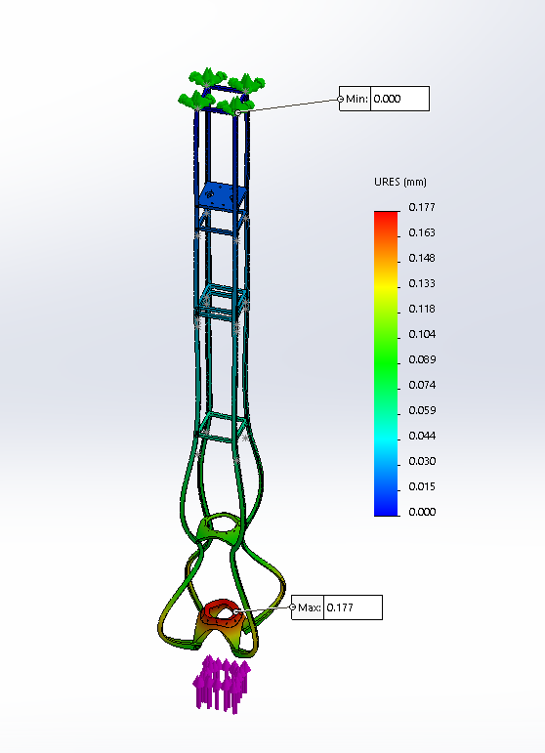

Figure 1 Displacement

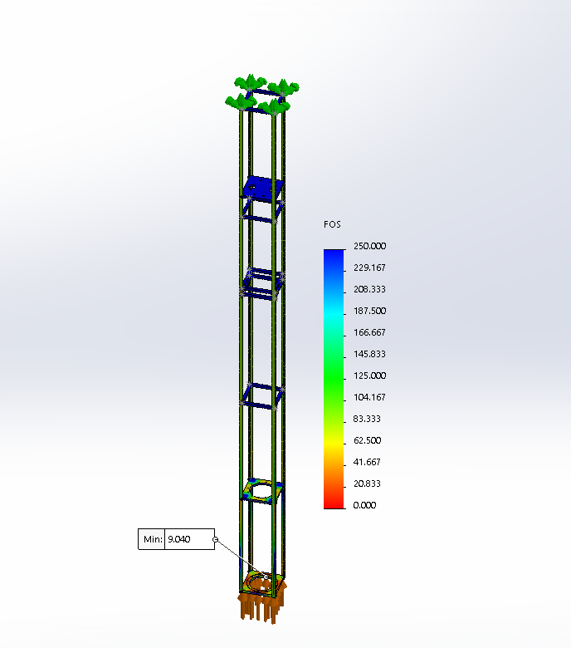

Figure 2 Factor of Safety

The two static force simulations above were done in SOLIDWORKS under static simulation. A combined 200 lbf force was distributed to the top and bottom separation plates of the combustion chamber section. The top of the frame structure was fixed. In Figure 1 we see the maximum and minimum displacement, 0.177mm and 0.001 mm, respectively. In Figure 2 we see the factor of safety across the entire structure, the lowest FOS is seen in the bottom combustion chamber separation plate of 9.04.

Rocket Frame

The image below is a summary of each component within the rocket. We thought it was important to simulate and model the rocket in its entirety, as well to aide visualization of our rocket.

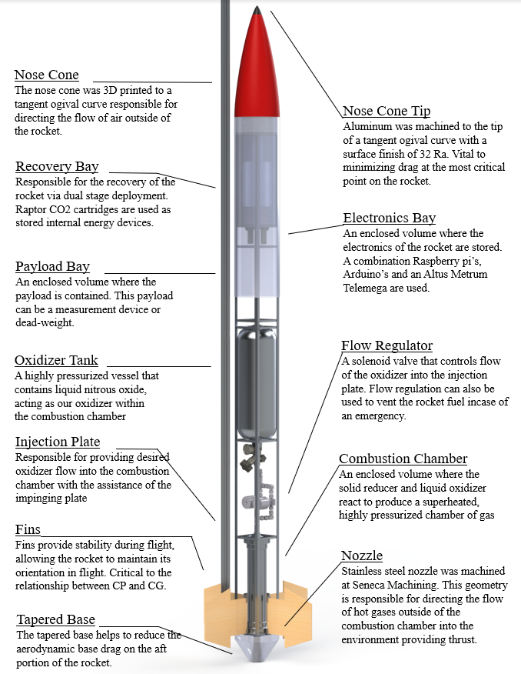

**Propulsion**

August 20th, 2019 Hot fire test

On August 20th, 2019 UNH SEDS conducted its first of three hot fires for 2019-2020. This hot fire test was conducted with “V1”. The 2018-2019 hybrid engine utilizing hydroxyl-terminated polybutadiene (HTPB) and liquid nitrous oxide as our fuel and oxidizer, respectively. Ron O'Keefe was present as our "field admin / field officer".

An unscheduled disassembly of the graphite nozzle led to inadequate data for analysis. Excess pressure and force from the engine sheared the nozzle in half, leaving only the flange attached to the chamber. Graphite was initially used due to its ablative properties, but its lack in strength lead to a transition to stainless steel for all remaining nozzle designs.

Videos of the August 20th hot fire can be found here:

<https://www.youtube.com/watch?v=wvJ64NYke1E&list=PL2W_-wg2HkvchByPzP4cCf5fGdk-m4BNR>

March 6th, 2020 hot fire test

On Friday March 6th we attempted our first hot fire of the semester. This was conducted with a new version of our combustion chamber and nozzle (V2). V2 consisted of paraffin wax as a fuel and nitrous oxide as an oxidizer. Ron O'Keefe was present as our "field admin / field officer".

This test was semi-successful, our ignition, flow regulation, and data collection systems preformed perfectly (which was a first). Specific impulse is a measure of how effectively a rocket uses propellant as fuel. We achieved an Isp=177.12 sec. The actual combustion was where we fell short, we achieved a maximum thrust of 25 lbf, our engine lacked the temperature and pressure required for stable combustion.

Videos of the March 6th hot fire can be found here:

<https://www.youtube.com/watch?v=ypyux8PbdT0&list=PL2W_-wg2HkveXkOyWUepFF58DycsICD-k>

March 12th, 2020 hot fire test

Friday March 12th was our second hot fire. This hot fire used the same combustion chamber and nozzle as Hot fire #1. Paraffin wax and nitrous oxide were used as a fuel and oxidizer respectively and like Hot fire #1. Kevan Carpenter was present as our "field admin / field officer".

Three changes were implemented to the overall system in order to hopefully improve the temperature and pressure of the combustion. First, we added 0.05% by weight Ferrocene Catalyst to the paraffin wax, this acted to accelerate the burning of the wax fuel. Secondly, we shrunk the nozzle throat diameter to 0.5" compared to 0.75" from Hot fire #1 in hopes to increase chamber pressure. Lastly, we increased the size of our igniter in order to get an equal burn throughout the engine.

This test was semi-successful. Again, ignition, flow regulation, and data collection systems preformed perfectly. Combustion was again were we fell short, we achieved a maximum thrust of 45 lb-f, an Isp=318.522 sec was recorded. Our engine had ample temperature, but combustion was unstable and non-uniform throughout the engine. Due to variations in the fuel during casting, some parts of the combustion reached the aluminum chamber walls prior to other parts. Resulting in the combustion melting through the aluminum chamber and starting an aluminum metal fire consuming the combustion chamber. Our thermocouple was consumed within the fire, resulting in corrupted thermocouple data.

Videos of the March 6th Hot fire can be found here:

<https://www.youtube.com/watch?v=Ln4uMyJjI1U&list=PL2W_-wg2HkvdFUfZrfqPiwb5tF9p7X4bD>

Note: The darker smoke is due to the presence of the Ferrocene Catalyst in the paraffin wax.

Conclusion

UNH SEDS has been my senior project for the past three years. I am fortunate to have acted as the clubs Vice President since Spring 2017, and the frame lead for the 2019-2020 academic year. It allowed me to start a career in the field I always dreamed of going into, build friends, and so much more. This team is something I am immensely proud of; I hope it continues to host a community within UNH CEPS for years to come. Through three hot fire tests and the development of our rocket, this year has been both incredible and challenging.

*Per Aspera Ad Astra*

A huge thanks to all the members of UNH SEDS, Scott Campbell, Ronald O’Keefe, Dr. Ivo Nedyalkov, Dr. Alireza Ebadi, Sheldon Parent, James Abare, Andy Globe, Dave Emanuel, Adam Smith, Chief Dean, TURBOCAM International, Reilly Webb, Ross Thyne, Seneca Machining, the UNH Makerspace and our Mechanical Engineering advisor Dr. Todd Gross for all the support.